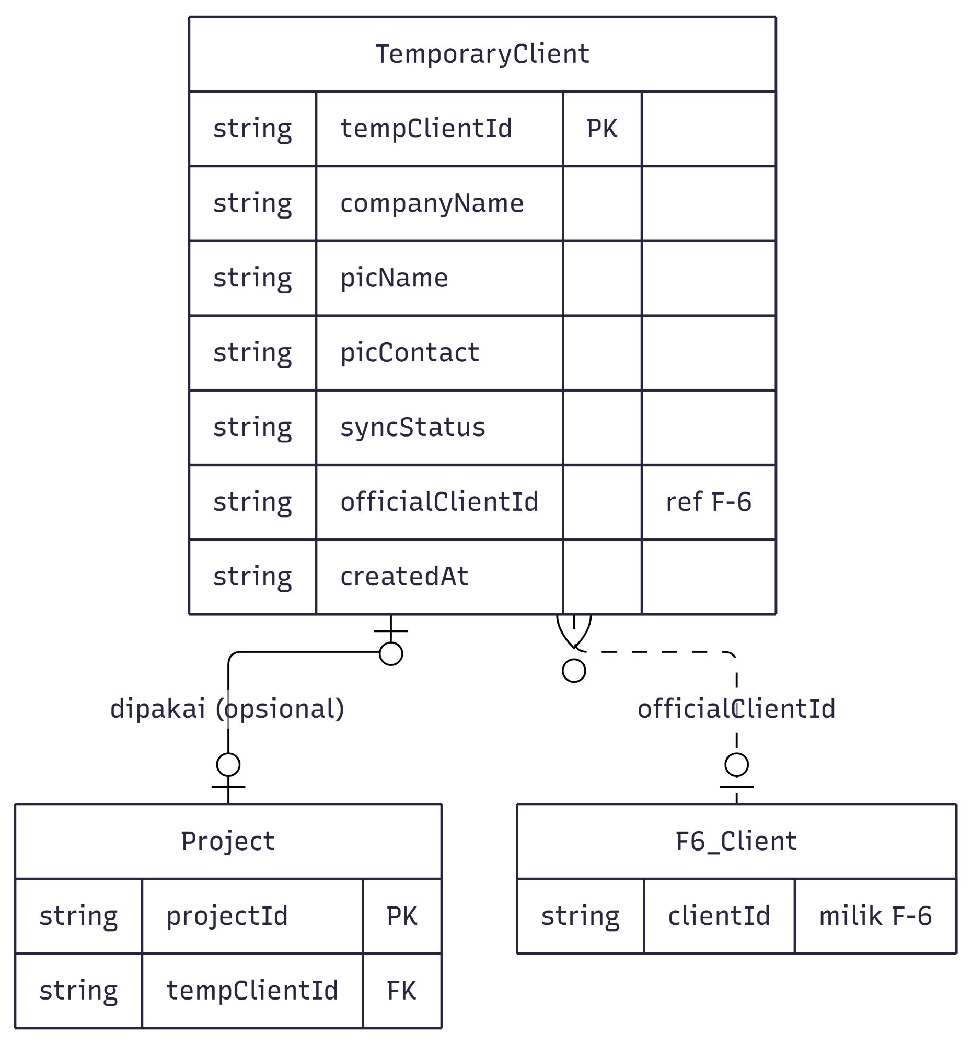
TemporaryClient
string tempClientId
string companyName
string picName
string picContact
PK
string syncStatus
string officialClientId
ref F-6
string createdAt
古
|
dipakai (opsional)
officialClientId
|
Project
F6_Client
string projectId
PK
string
clientId
milik F-6
string tempClientId FK

